**Vision**

**Revision History**

|  |  |  |  |
| --- | --- | --- | --- |
| Version | Date | Description | Author |
| inception draft | Oct 18,2021 | First draft. To be refined primarily during elaboration. | markdoge |
| … | … | … | … |

**Introduction**

The statistical analysis module can monitor the distribution and risk of visitors. After connecting with health kit, get the area where the visitor has been. If the visitor goes to an area with high risk, give a system prompt.

**Positioning**

***Business Opportunity***

nein

***Problem Statement***

The general analysis and statistics system is only connected to the local database and lacks the tracking of visitors' information. This can lead to a threat to the safety of residents.

***Product Position Statement***

Face recognition module services. It is characterized by connection with external data, which can not only identify whether the visitor is a resident, but also identify whether there is a risk.

***Alternatives and Competition***

**Stakeholder Descriptions**

An internal module, not user oriented

***Market Demographics…***

***Stakeholder(Non-User) Summary…***

***User Summary…***

***Key High-Level Goals and Problems of the Stakeholders***

|  |  |  |  |
| --- | --- | --- | --- |
| High-Level Goal | Priority | Problems and Concerns | Current Solutions |
| Runnable，Accurate ， fast | High | Connect to healthy kit.  Ways to Combine face and information.  User privacy issues | Use official API and Encapsulate user information and only the kernel can use it. |
| … | … | … | … |

***User-Level Goals***

An internal module, not user oriented

***User Environment***

Send warning message.

**Product Overview**

***Product Perspective***

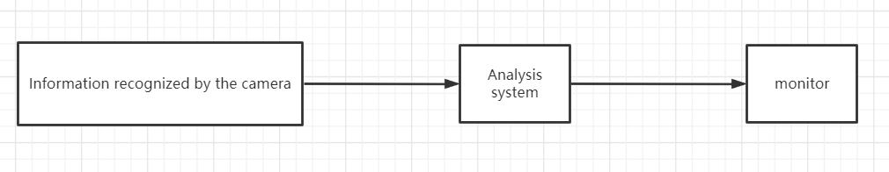

***Summary of Benefits***

|  |  |
| --- | --- |
| Supporting Feature | Priority |
| Analyze the epidemic risk of the characters captured by the camera | Ensure the health of residents |
| Distribution the analysts of residents | Easy to manage |
| … | … |

***Assumptions and Dependencies…***

Official database support

***Cost and Pricing…***

Connect to the official database

***Licensing and Installation…***

**Summary of System Features**

* 1. Comparison of local information and online information.
* 2. Identification residents who come from risk areas.
* 3. Output warning after recognition.
* …